Notes: Combining Like Terms-
Name: ____________________
Date: ___________
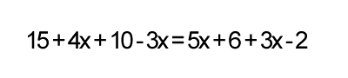
First you combine like terms!
The "like terms" in the equation above are ones that have the same variable. All constants are like terms as well. This means that the 15, 10, 6, and -2 are all one set of like terms, and the other is 4x, -3x, 5x, and 3x. To combine them is pretty easy; you just add them together and make sure that they are all on the same side of the equation. First, we will combine all like terms on each side of the equation:
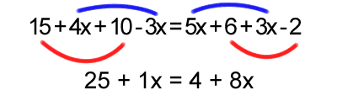
Then you solve!
25 + 1 X = 4 + 8X
-1X = -1X
25 = 4 + 7X
-4
25-4= 7x
21= 7X
21/7= 7X/7
X = 3

