Section 1-1 Notes: Real Numbers
Intro: There are many different types of numbers and they’re often related to each other.
Natural (Counting) Numbers: 1, 2, 3, ...
Whole Numbers: 0, 1, 2, 3, ...
Integers: ..., -3, -2, -1, 0, 1, 2, 3, ...
Rational Number: (Fraction) ª/_{b} where a and b are integers and b 0. (Rational numbers always terminate OR repeat)
Examples: ³/₄; -0.1765451; .23232323...
Irrational Numbers: Not rational, meaning nonterminating and nonrepeating.
Examples: ¹; e;
Real Numbers: The set of all rational and irrational numbers
So how are these dudes all related?
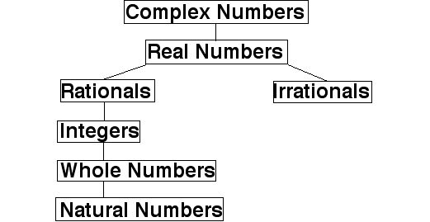
Properties of Real Numbers
Property | Addition | Multiplication
Closure | a + b is a real # | a • b is a real #
Commutative | a + b = b + a | ab = ba
Associative | a + (b + c) =  (a + b) + c | a(bc) = (ab)c
Identity | a + 0 = a | a • 1 = a
Inverse | a + (-a) = 0 | a •¹/_{a} = 1; a 0
Distributive Property: a(b + c) = ab + ac

Closure: Operation on two members of the set yields another member of the set
This means if you add any two real numbers
a and b, then a + b will be a real number too!
Your turn: Identify the properties shown below
a. (3 + 9) + 8 = 3 + (9 + 8) b. 14 • 1 = 14
Note:
- (-a) is also called the additive inverse of a
- ¹/_{a} is also called the reciprocal of a
Definitions:
Subtraction: a - b = a + (-b)
Division: ª/_{b} = a • ¹/_{b}
Subtraction = difference addition = sum
Division = quotient multiplication = product
_{Unit (Dimensional) Analysis}
Units work just like variables do!
Examples:
a. 345 miles - 120 miles = 225 miles
b. (2 hours)(60 ^{miles}/_{hour}) = 120 miles
c. ^{$24}/_{3 hours} = ^{$8}/_{hour}
_{d. (}^{40 feet}/_{second})(^{60 seconds}/_{min}) =
2400 ^{feet}/min

Your turn: Simplify
a. If you’re driving 45 miles per hour. How many feet per second are you driving?
(Hint: 5280 feet = 1 mile)

Section 1-2 Notes: Algebraic Expressions and Models
Numerical Expression: Working with numbers
Algebraic Expression: Working with variables
Example: 2⁵ = 2 • 2 • 2 • 2 • 2 = 32
“2” is the base “5” is the exponent
Order of Operations: PEMDAS
P = Parentheses (grouping symbols)
E = Exponents
MD = Multiplication/Division (from left to right)
AS = Addition/Subtraction (from left to right)
Example: Simplify -4 + 2(-2 + 5)²
Solution: -4 + 2(3)² (Did parentheses)
= -4 + 2(9) (Did exponent)
= - 4 + 18 (Did multiplication)
= 14 (Did addition)

Substitution Property
Example: Evaluate -3x² - 5x + 7 when x = -2
Solution: -3(-2)² - 5(-2) + 7 (Substitute x = -2)
= -3(4) - 5(-2) + 7 (Did Exponent)
= -12 + 10 + 7 (Did Multiplication)
= 5 (Did Addition)
Definitions: Example:
Constant: a number 3
Variable: a letter x
Coefficient: number in front of a letter 4 in 4x
Example: You want to buy either a CD or a cassette for 10 people. CDs cost $13 each and cassettes cost $8 each. Write an expression for the total amount you must spend.
Solution:
(1) Define your variables
Let x = # of CDs, y = # of cassettes, C = Cost
(2) Write your expression
13x + 8y = C
Your turn: How much would it cost you if you gave 4 people cassettes and the rest CDs?

